1. **FREQUENCY RESPONSE OF CE AMPLIFIER**

**AIM:** 1. To obtain the Frequency response characteristics of Common emitter amplifier and

1. To determine the Bandwidth.

**APPARATUS:**

|  |  |  |  |  |
| --- | --- | --- | --- | --- |
| S.No | Apparatus | Type | Range | Quantity |
| 01 | Transistor | BC107 |  | 01 |
| 02 | Resistance |  | 33KΩ,4.7 KΩ,2.2 KΩ  8.2 KΩ,1 KΩ | 01 |
| 03 | Regulated Power supply |  | (0-30V) | 01 |
| 04 | Capacitor |  | 10µF | 03 |
| 05 | Signal Generator |  | 10-1M Hz | 01 |
| 06 | CRO |  |  | 01 |
| 07 | Breadboard and Wires ,CRO  Probes |  |  |  |

**CIRCUIT DIAGRAM:**

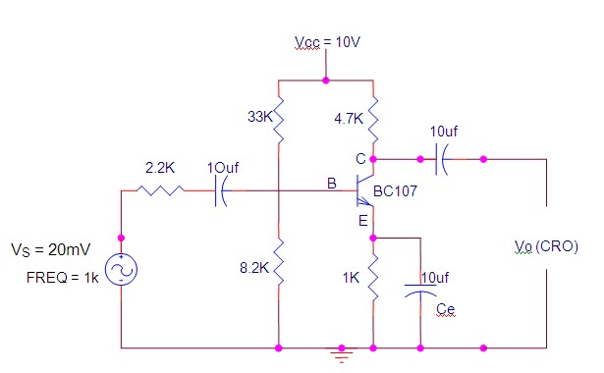

**PROCEDURE:**

1. Connections are made as per the circuit diagram.
2. A 10V supply is given to the circuit.
3. A certain amplitude of input signal (say 20mv at 1 kHz) is kept constant using signal generator and for different frequencies, the output voltage (V0) from CRO are noted.

# *V*0

1. Gain for with and without feedback is calculated using *Gain*(*dB*)  20log ; Where Vo *Vi* is output voltage, Vi is input voltage.
2. Plot the graph between Gain(in dB) and frequency.

**OBSERVATION:**

CIRCUIT DIAGRAM

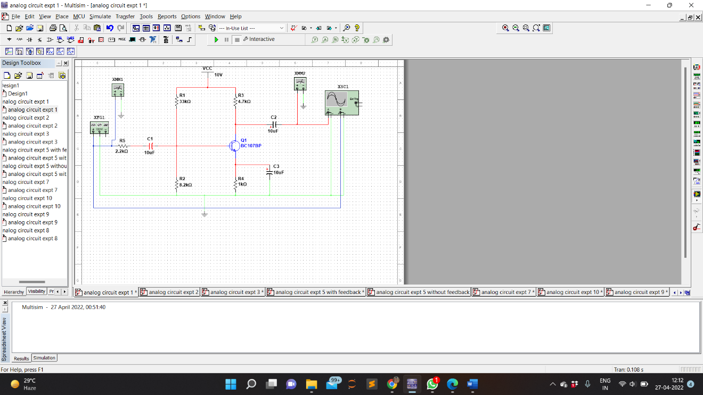WAVEFORM

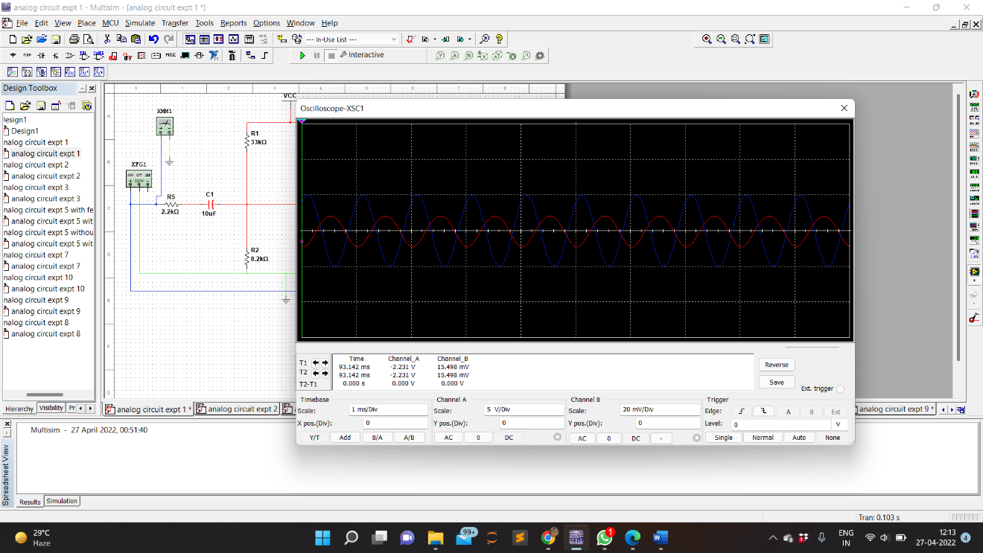

OUTPUT VOLTAGE

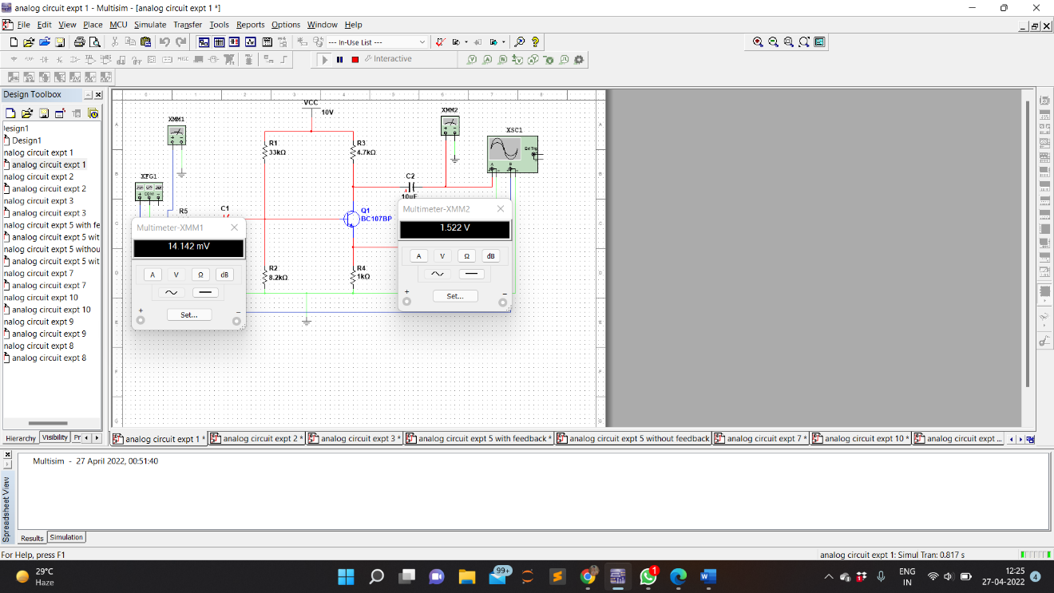

**TABULAR COLUMN:**

|  |  |  |  |  |
| --- | --- | --- | --- | --- |
| S.no. | Input frequency (Hz) | o/p voltage(vo)  (mv) | voltage gain  *V*  Av= 0  *Vi* | *V*  *Gain*(*dB*)  20log 0  *Vi* |
| 1.  2.  3. | 100Hz    1KHz  1MHz | 302.916 mV  1.522 V  367.217 mV | 21.419  107.636  25.479 | 26.614  40.62  28.12 |

**MODEL GRAPH:**

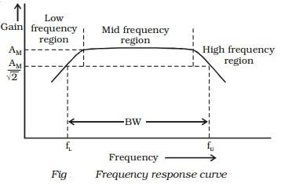

**Caluculations from Graph**

1.Draw a line at maximum gain(dB) less than by 3dB parallel to the X-axis as shown in the figure

2.Draw two lines at the intersection of the characteristic curve and the 3dB line onto the X-axis which gives the (fH) and (fL)

3.The difference between fH and fL gives the Bandwidth of the amplifier.

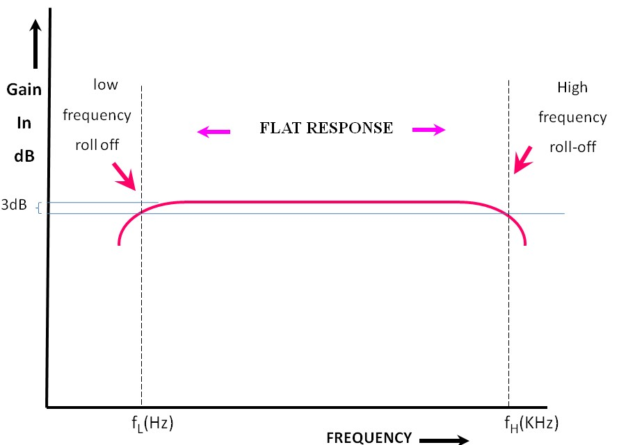

**BANDWIDTH GRAPH:**

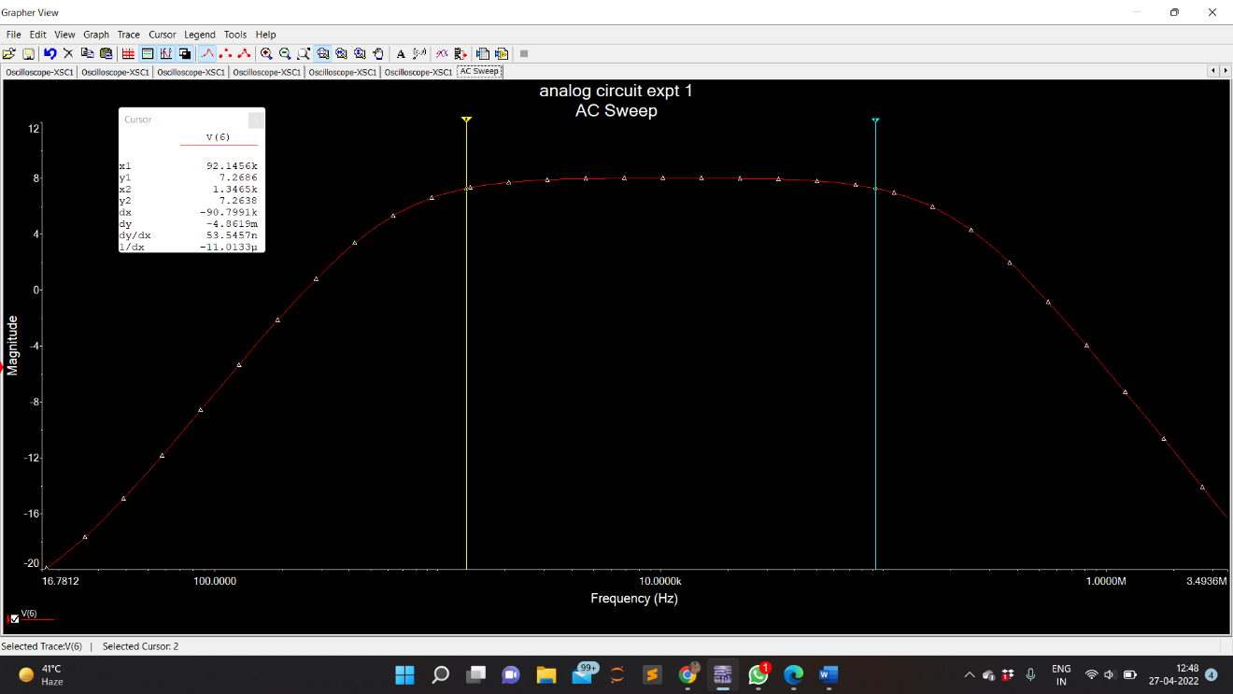

**CALCULATION:**

1. Input Frequency = 100 Hz

Output Voltage (Vo) = 302.916 mV

Input Voltage (Vin) = 14.412 mV

So , Voltage gain = Vo/Vin **=** 302.916mV/14.412mV

= 21.419

Gain (dB) = 20 log Vo/Vin = 20 log (21.419)

= 26.614

1. Input Frequency = 1 kHz

Output Voltage (Vo) = 1.522 V

Input Voltage (Vin) = 14.412 mV

So , Voltage gain = Vo/Vin **=** 1.522V/14.412mV

= 107.636

Gain (dB) = 20 log Vo/Vin = 20 log (107.636)

= 40.62

1. Input Frequency = 1 MHz

Output Voltage (Vo) = 367.217 mV

Input Voltage (Vin) = 14.412 mV

So , Voltage gain = Vo/Vin **=** 367.217mV/14.412mV

= 25.479

Gain (dB) = 20 log Vo/Vin = 20 log (25.479)

= 28.12

Bandwidth = f**high –** f**low** = 92.1456 kHz – 1.3465 kHz = 90.7991 kHz

**PRECAUTIONS:**

1. While doing the experiment do not exceed the ratings of the transistor. This may lead to damage the transistor.
2. Do not switch **ON** the power supply unless you have checked the circuit connections as per the circuit diagram.
3. Make sure while selecting the emitter, base and collector terminals of the transistor.

**RESULT:**

Frequency response characteristics of Common emitter amplifier is studied through the circuit designed and voltage gain and bandwidth has been studied and calculated.